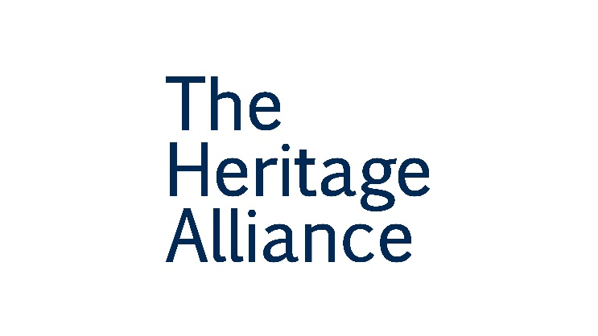
Communications Manager

Permanent contract, full time role
Salary – £28,000 pa
Holiday – 24 days + plus bank holidays + period between Christmas and New Year

Location – The Heritage Alliance Office, London (with hybrid working options)
Closing date: 14 February 2023

Are you looking to make a positive change for the heritage sector? Are you an enthusiastic and persuasive communicator who can engage and influence through various channels? Come and work at The Heritage Alliance!

We are looking for an experienced and passionate Communication Manager to join our small but effective team. Reporting to the Head of Policy, you will lead on all THA communication channels, including compiling and editing our fortnightly newsletter, Heritage Update. You will work with THA colleagues to deliver our communications strategy, with key responsibilities for social media content, website updates, and communication planning for our two annual events, Heritage Debate and Heritage Day. Your remit will also cover key communications projects, such as the website update project. As part of the Policy team, you will also contribute to the advocacy work of THA, assisting with running our Advocacy Groups and coordinating consultation responses.

Person Specification:

Essential
- A proven strategic thinker, you can demonstrate your experience delivering coordinated pro-active and reactive content across Social Media (Twitter, Facebook, LinkedIn), websites and newsletters. You will be familiar with website editing.
- Clear and persuasive writing for multiple audiences across various channels, you can use the key features of different types of media to their full effectiveness.
- Demonstrable interest in heritage policy and political awareness, you are aware of the main issues facing the heritage sector.
- Strong research skills, you will be familiar with the key sources of political and sector information, as well as some experience in horizon scanning to identify emerging trends. You can distil multiple information channels into summaries and usable comms products.
- A proficient Stakeholder manager, you have the ability to build strong working relationships with Alliance members, politicians and other sector contacts.
- An efficient project manager, you can manage a busy workload and deliver on multiple workstreams through prioritisation and excellent time management.

Desirable
- Experience of working in a membership organisation.
- Experience with website coding, specifically html, and web design.
- Knowledge of Adobe Creative Cloud programmes and Canva (or similar software), with the ability to edit and typeset documents and visuals.
- Events experience.
- Line management experience (you will manage interns at THA).

You can find the full job description on our website. If you have any questions about the role, or would like an informal conversation ahead of applying, please get in touch with either the outgoing Communications Manager Daniella Briscoe-Peaple, (comms@theheritagealliance.org.uk), or our CEO, Lizzie, (lizzie.glithero-west@theheritagealliance.org.uk).

To apply for the role, please send a copy of your CV and a completed application form to projects@theheritagealliance.org.uk by 23.59 on 14th February. Interviews for successful candidates will be held via Zoom on 23rd February.

Communications Manager

Job Description

Key Tasks:

Comms Work:
- Leading on the delivery of communications campaigns, products and engagement across The Heritage Alliance
- Managing social media channels, coordinating content, and designing and delivering campaigns
- Full responsibility for Heritage Update, including:
  - Managing email folder
  - Gathering content from a range of sources independently, keeping up with policy news
  - Responding to requests
  - Managing advertising
  - Managing coverage when on Annual Leave
- Producing and delivering reporting on communications for funders and the Board
- Regular maintenance of the Heritage Alliance website
- Management of Heritage Funding Directory Project, including budget and sponsorship
- Supporting the management and organisation of sector events

Advocacy Work:
- Progressing special advocacy projects
- Reactive advocacy work in coordination with the HoP
- Writing members’ communications/emails
- Supporting the HoP running Advocacy Groups, including minute taking and preparing papers
- Writing the initial drafts of briefing and consultation responses
- Maintaining the information Hubs on the website (as appropriate)
- Proactive parliamentary monitoring

Administrative Work:
- Supporting the Board Secretariat in their tasks
- Supporting Company Secretary in their tasks
- Diary management and coordination of large meetings, such as sending invitations and organising rooms, as well as taking minutes
- Management of interns/volunteers as appropriate

Please note, at times some of these tasks will be undertaken by a Government Fast Streamer Secondee. Tasks will be delegated out within the Advocacy and Communications Team, by the Head of Policy (HoP).

